Session 7. Ex-ante Assessment of Tax Expenditures (Group A)
India is crafting its decarbonization strategy to achieve its net-zero objectives of achieving net carbon-zero, improving air quality levels, and cutting fossil fuel imports. Against this context, the government is considering cutting the goods and services tax (GST) rate on hybrid vehicles from 28% to 12% as a step to change the composition of the vehicle fleet and its energy consumption.
  - Based on the following pieces of information, the minister is asking your team to conduct an ex-ante assessment of this measure, focusing on
- relevance & rationale, and
- cost
- India's combined sales and additional taxes on hybrid vehicles sales are as high as 43%, based on the size of the car, relatively close to the highest rate of 50% imposed on petrol and diesel cars.
- Life-cycle green house gas (GHG) emissions by type of engine:
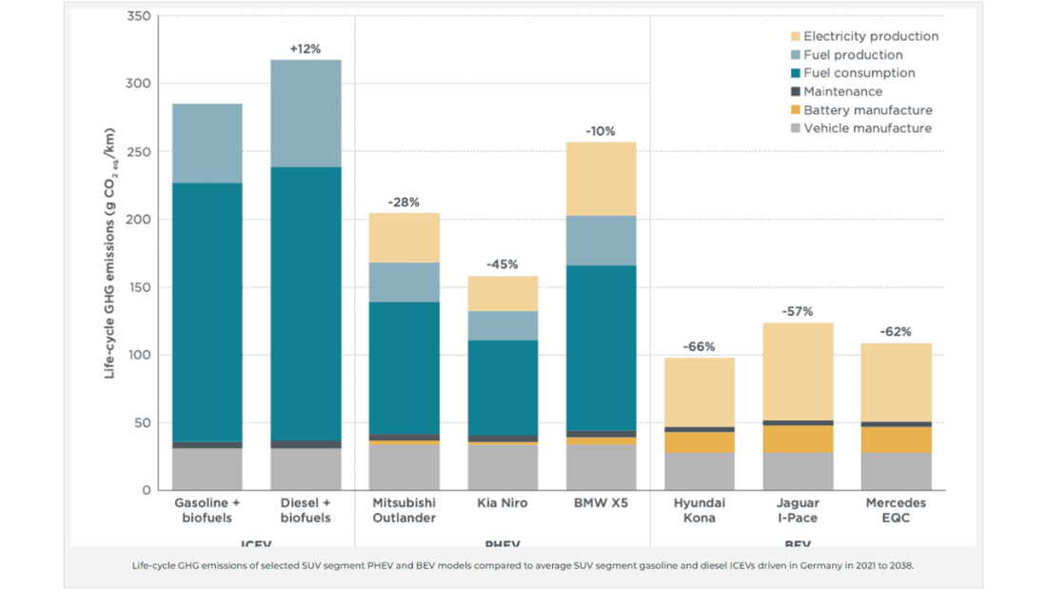
Source: The International Council on Clean Transportation, 2022

- Tax incentives (including a reduction of sales taxes) can significantly increase car sales.
  - After Colombia significantly reduced sales taxes and nearly eliminated import tariffs on hybrid and electric vehicles in 2017, a major increase sales was observed, with the combined market share of plug-in electric vehicles (EVs) and hybrid cars reaching 5%, which placed Colombia second after China among developing countries (World Bank, 2022).
- The average price (before GST) of an hybrid car in India is: 30,000 USD and, on average, 8,000 hybrid cars are sold in India every month.

1.2.A – Your team has gathered additional relevant information and you consider it is worth running the ex-ante assessment again, this time focusing also on:
- efficiency,
- side effects or externalities, and
- policy coherence

- Hint: Accounting for behavioural changes, the fiscal cost is likely to be different compared to the static revenue forgone calculation.
- As the car industry in India is highly concentrated, the reduction in GST might not be fully passed through to consumers.
  - Hence, the new average price of hybrid cars under the partial pass through scenario would not be 33,600 USD but rather 35,000 USD.
- Based on Fridstrøm and Østli (2021), the own-price elasticity of hybrid cars is estimated at -1.72.
  - Hence, the estimated quantity of hybrid cars sold is now 110,620 per year.
- The government collects a significant amount of tax revenue through excise taxes on gasoline and diesel
- EVs, already face a reduced GST rate of 5% (again, compared to the standard 28% rate), which is justified on the grounds of their significant smaller life cycle emissions.
- According to the local industry, hybrids in India actually use a small battery pack and a motor that relies heavily on a fossil-fuel engine, effectively making them gasoline-run vehicles.
- While hybrids in India are mainly produced by foreign carmakers (mainly the big Japanese and Korean brands), local car producers (such as Tata and Mahindra & Mahindra) have already invested heavily to transition to EV production.
- According to the energy industry, the electrification of rural India for EVs presents a promising future. With the integration of clean and renewable energy sources, the development of charging infrastructure, and the economic benefits it brings, rural India can actively participate in the electric mobility revolution. In other words, the development of electric infrastructure for EVs in rural areas holds immense promise, offering numerous benefits to the environment, the economy, and the people.
- Women buyers are increasingly choosing EVs in India, with one out of every four EVs sold being purchased by women. Indeed, women account for roughly 23-24% of EV sales, but only 11-12% for petrol and diesel cars, and slightly higher figures for hybrids.

